**MEPS Website Assessment Report III, Part A**   
Card Sort Analysis and Proposed Navigation

Report prepared on July 28, 2022, by Pantheon and AIR for the Agency for Healthcare Research and Quality

Table of Contents

Overview 4

Introduction 4

Methodology 4

Analysis 7

General Results 7

Manual Analysis 8

About Section 9

Survey/Questionnaire Information Section 9

Household Component, Insurance Component, Medical Provider Component, Nursing Home Component Sections 10

Data Section 10

Publications Section 10

Events, Webinars, and Conferences Section 11

News Section 11

Automated Analysis 11

Similarity Matrix 11

Similarity Matrix Findings 12

Dendrograms 14

Dendrograms Findings 15

Recommendations 19

Option 1 20

Option 1 Primary Navigation Site Map 21

Option 2 23

Option 2 Primary Navigation Site Map 24

Conclusions 26

Table of Exhibits

Exhibit 1: Listing of Cards in Card Sort Activity 5

Exhibit 2: User Results for Card Sort Exercise 7

Exhibit 3: Similarity Matrix Showing 100% Agreement Between Two Cards 12

Exhibit 4: Similarity Matrix Showing 61% Agreement Between Two Cards 12

Exhibit 5: A Mock Dendrogram Showing Agreement Among 75% of Users 14

Exhibit 6: Dendrogram Showing the Household Component Grouping 16

Exhibit 7: Dendrogram Showing the Insurance Component Grouping 17

Exhibit 8: Dendrogram Showing the Medical Provider Component Grouping 17

Exhibit 9: Dendrogram Showing the Nursing Home Component Grouping 18

Exhibit 10: Dendrogram Showing the Publications Grouping 18

Exhibit 11: Dendrogram Showing the About MEPS Grouping 19

Exhibit 12: Dendrogram Showing the Restricted Data Grouping 19

Exhibit 13: Example Visual Mock-Up of Option 1 21

Exhibit 14: Option 1 Site Map 21

Exhibit 15: Example Visual Mock-Up of Option 2 23

Exhibit 16: Option 2 Site Map 24

# Overview

For this report, Report III, Part A: Card Sort, the American Institutes for Research (AIR) and Pantheon (the AIR team) present the methodology and card sort analysis results for the data on the Agency for Healthcare Research and Quality (AHRQ) Medical Expenditure Panel Survey (MEPS) website. We then provide recommendations for two navigation options for the MEPS website redesign that were tested during the Tree Test phase of the website assessment.

# Introduction

Card sorting is a powerful tool for user research. In this interactive activity, users are given a list of content and features for a website and asked to group them in ways that make sense to them. Once finished, the user gives each group a name to define each new grouping. The purpose of the card sort exercise is to see how users think the different types of content should be organized throughout the site and inform the navigational structure. For instance, one user might think that all data files should be grouped together, whereas another user might think that data files should be separated out by their parent category, such as Household Component or Insurance Component. Through analyzing card sort exercises completed by many types of users, one may notice trends in the way users expect items to be grouped, which can then help in the structuring of content on the site.

# Methodology

The UX team sent the card sorting exercise to Medical Expenditure Panel Survey (MEPS) website users over a period of 4 weeks beginning in late April 2022. Users were taken to the Optimal Workshop website to begin the card sorting exercise. The exercise was sent out and completed anonymously; however, we required all users to select the organization to which they belonged: Agency for Healthcare Research and Quality (AHRQ), American Institutes for Research (AIR), or Other. The exercise then gave users a set of instructions along with 54 content items to group within an interactive web interface (see Exhibit 1). Once the user created the groups, each user named each group in a way they thought accurately described the content within the group and submitted their results.   
  
The first round of users we asked to complete the exercise were members of AHRQ and AIR who previously had participated in user interviews in the first part of the assessment. In total, we sent 23 card sort exercises to internal users, with 15 of those going to AHRQ and 8 going to AIR. At the end of the 4 weeks, 19 of the 23 users completed the exercise. The second round of users we asked to complete the exercise were external users from either the Household Component or Insurance Component interviews. These external users consisted of members of organizations that use the MEPS website on a regular basis. AIR sent the activity to 12 external users, and 7 of those users (5 Household Component and 2 Insurance Component interviewees) completed it successfully.

Exhibit 1: Listing of Cards in Card Sort Activity

|  |
| --- |
| Background information about the MEPS Household Component |
| Objectives, instruments, and procedures for data collection in the Household Component |
| Panel design and data collection process for the Household Component |
| Standard errors for MEPS estimates for the Household Component |
| Response rates for the Household Component |
| Background information about the MEPS Insurance Component |
| Objectives, instruments, and procedures for data collection in the Insurance Component |
| Sample design and data collection process for the Insurance Component |
| Sample size for the Insurance Component |
| Technical notes and survey documentation for the Insurance Component |
| National level data tables for the Insurance Component |
| State and metro level data tables for the Insurance Component |
| Background information about MEPS Medical Provider Component |
| Objectives, instruments, and procedures for data collection in the Medical Provider Component |
| Authorization forms for the Medical Provider Component |
| Sample sizes for the Medical Provider Component |
| Data elements for the Medical Provider Component |
| Contact guides for the Medical Provider Component |
| Questionnaires for the Household Component |
| Supplemental paper questionnaires for the Household Component |
| Private sector establishment questionnaires for the Insurance Component |
| State and local government questionnaires for the Insurance Component |
| Questionnaires for the Medical Provider Component |
| Background information about MEPS Nursing Home Component |
| Questionnaires for the Nursing Home Component |
| Search for PUFs—Household Component |
| Types of PUFs—Household Component |
| PUF documentation—Household Component |
| PUF Codebook PDF/HTML—Household Component |
| PUF programming SAS, SPSS, Stata, and R statements—Household Component |
| PUF data in SAS format—Household Component |
| PUF data in Stata format—Household Component |
| PUF data in ASCII format—Household Component |
| PUF data in XLSX format—Household Component |
| Information on accessing restricted data sets |
| Application for access to restricted data |
| Search for publications |
| Find publications by topic |
| Statistical brief (Example: Concentration of Healthcare Expenditures and Selected Characteristics of High Spenders, U.S. Civilian Non-institutionalized Population, 2018) |
| Chartbook (Example: Changes in Preventive Service Use by Race and Ethnicity After Medicare Eligibility in the United States) |
| Methodology report (Example: Sample design of the 2014 Medical Expenditure Panel Survey Insurance Component) |
| Basic information explaining features related to AHRQ data tools |
| Link to AHRQ data tools for Household Component |
| Link to AHRQ data tools for Insurance Component |
| Household Component variable explorer tool that allows users an easy way to find variables for research purposes |
| Information about MEPS webinars |
| Information about MEPS workshops |
| Information about MEPS conferences |
| A webinar about analyzing MEPS data using SAS |
| Information about the release schedule for PUFs for the Household Component |
| Information about upcoming data sets, publications, and webinars |
| Information about newly released data sets, publications, and webinars |
| Join the MEPS mailing list |
| Letter thanking participants for helping with MEPS research |

# Analysis

For the analysis stage, we used two methods to sort through and understand the data. The first method was a manual analysis. In this method, we downloaded the results for each user and imported them into a spreadsheet. From there, we could manually sort through the responses and see trends for how different users were thinking similarly throughout the exercise. The second method was an automated analysis. In this method, we used Optimal Workshop’s tools to see what trends were generated from the user submissions. From there, we were able to see what areas the manual and automated analyses compared similarly and draw a more accurate conclusion.

## General Results

Of the 35 users we asked to complete the card sort exercise, 26 users successfully completed it (see Exhibit 2). The median time to completion was 16 minutes and 54 seconds. Throughout the exercise, users could group the 54 content items into as many or as few groups as they chose. The user with the most groups had 22 categories. The user with the fewest groups had only five categories. The most common number of categories was eight, which appeared on the submissions of seven users. Finally, the median for categories was between eight and nine.

Exhibit 2: User Results for Card Sort Exercise

|  |  |  |
| --- | --- | --- |
| Participant | Number of Categories | Time to Completion |
| p5 | 9 | 51:49 |
| p7 | 5 | 6:17 |
| p8 | 12 | 1:04:10 |
| p10 | 22 | 17:43 |
| p11 | 10 | 9:26 |
| p12 | 10 | 22:36 |
| p13 | 8 | 16:05 |
| p14 | 10 | 21:12 |
| p16 | 8 | 10:07 |
| p17 | 12 | 48:41 |
| p19 | 10 | 19:03 |
| p20 | 13 | 28:08 |
| p21 | 8 | 11:20 |
| p22 | 11 | 17:54 |
| p23 | 7 | 11:58 |
| p25 | 7 | 11:15 |
| p26 | 9 | 13:48 |
| p28 | 5 | 24:18 |
| p29 | 8 | 9:42 |
| p30 | 5 | 13:17 |
| p31 | 20 | 44:16 |
| p32 | 11 | 15:41 |
| p33 | 7 | 1:54:27 |
| p34 | 8 | 17:53 |
| p35 | 8 | 15:54 |
| p39 | 8 | 7:00 |
| Average | 9.7 | 25:02 |
| Median | 8.5 | 16:54 |
| Mode | 8.0 | N/A |

## Manual Analysis

In our manual analysis, AIR first examined all the categories that the users created. In total, the 26 participants created 251 categories. Because these were custom-created categories by each user, there were many unique names for the different groups of content. However, when manually inspecting and organizing the list of categories, we noted many commonalities and found 10 common category types. These were as follows:

* About
* Survey/Questionnaire Information
* Household Component
* Insurance Component
* Medical Provider Component
* Nursing Home Component
* Data
* Publications
* Events, Webinars, and Conferences
* News

### About Section

Within the *About* section, multiple users had an *About MEPS* group. We also saw other groups that would fall into this category, including *Background About MEPS*, *General Overview*, and *Information About MEPS*.

The most commonly found types of content items in this section included the following:

* Join the MEPS mailing list
* Information about upcoming data sets, publications, and webinars
* Letter thanking participants for helping with MEPS research
* Basic information explaining features related to AHRQ data tools

### Survey/Questionnaire Information Section

Within the Survey/Questionnaire section, the most common group was *Questionnaires*. We also saw *Methodology* and *Background Information* used multiple times.

The most commonly found types of content items in this section included the following:

* Questionnaires for Household Component
* Questionnaires for Insurance Component
* Questionnaires for Medical Provider Component
* Methodology reports

Most users grouped the survey/questionnaire information for components under each component’s category. For example, they grouped *Response rates for the Household Component* and *Questionnaires for Household Component* under *Household Component*.

### Household Component, Insurance Component, Medical Provider Component, Nursing Home Component Sections

Household Component was among the top two categories with the most cards within it (the Data section had the most categories). We found the section title *Household Component* or something similar among more than half of the users. In addition, we found other section titles that would fit inside a Household Component section such as *MEPS—Household Component Background* or *Household Component Documentation*. The same types of similarities occurred when we looked at Insurance Component, Medical Provider Component, and Nursing Home Component.

For each component section, similar trends emerged in the way users grouped the content, including the following:

* Background information for each component
* Public use file (PUF) data (under Household Component)
* Questionnaires and survey information

### Data Section

The Data section had the most cards grouped together. Many users used subcategories for Data, including *Data Background*, *Data Centers*, *Data Documentation*, *Data News*, *Data Support*, *Restricted Data Access*, and *Data Files*.

The most commonly found types of content items in this section included the following:

* PUF data
* Data tools
* Data elements for Medical Provider Component
* Accessing restricted data sets

### Publications Section

The Publications section had the most similar groupings across users of any section. The exact term *Publications* was a section title in half of all users’ submissions, and multiple other users had a similar term, such as *Agency Publications* or *General: Publications*.   
  
The most commonly found types of content items in this section included the following:

* Search for publications
* Chartbooks
* Statistical briefs

### Events, Webinars, and Conferences Section

Eleven users created an *Events, Webinar, or Conference* grouping. These names included *Training and Webinars*, *Webinars and Conferences*, *Upcoming Events and Webinars*, and other similar terminology.

The most commonly found types of content items in this section included the following:

* Information about MEPS webinars
* Information about MEPS workshops
* Information about MEPS conferences

### News Section

Six users created a *News* grouping in their exercise. They included terms such as *News*, *Info and News*, and *Latest News*.

The most commonly found types of content items in this section included the following:

* Information about newly released data sets, publications, and webinars
* Information about the release schedule for PUFs for the Household Component
* Information about upcoming data sets, publications, and webinars

## Automated Analysis

The application we used for this card sort activity, Optimal Workshop, provides a few helpful tools to analyze the submission data. One of those tools is called the *Similarity Matrix*.

### Similarity Matrix

The Similarity Matrix is a graphical tool that displays cards frequently paired together along with the percentage of users who paired them together. Highlighted in the example Similarity Matrix below, 100% of users grouped PUF data in ASCII format with PUF data in XLSX format (see Exhibit 3), which means that no user separated these two cards into different categories.

Exhibit 3: Similarity Matrix Showing 100% Agreement Between Two Cards

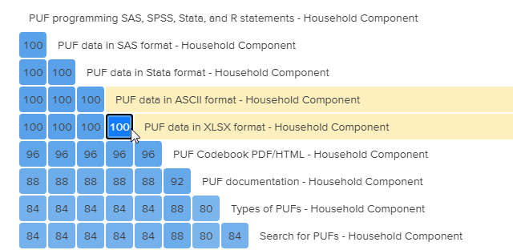

Because the Similarity Matrix is interactive, we can get more detailed information by selecting a square to see which column and row aligns with it. In the next example, we see that 61% of users grouped *PUF data in SAS format* with *Information about the release schedule for PUFs for the Household Component* (see Exhibit 4). This grouping gives us insight that most users agree that a PUF release schedule should be found within the same category as the PUF data.

Exhibit 4: Similarity Matrix Showing 61% Agreement Between Two Cards

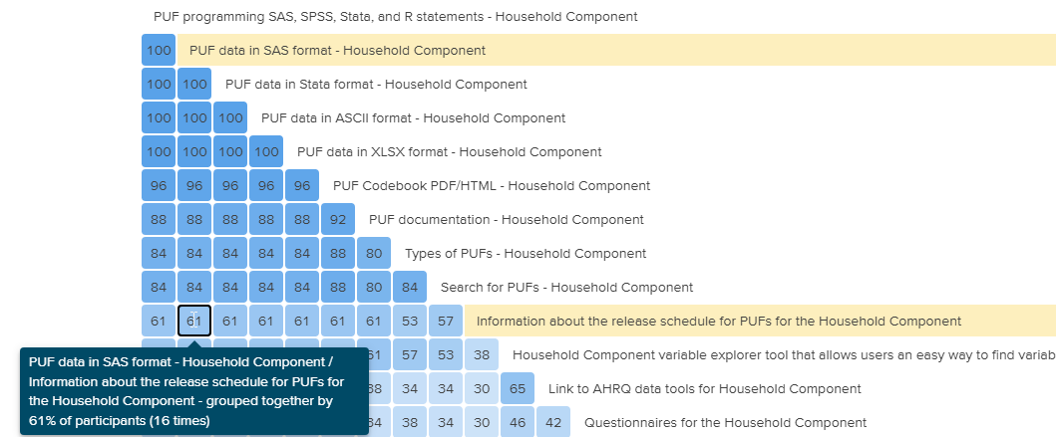

### Similarity Matrix Findings

When analyzing the data via the Similarity Matrix, we found that users created the following groups most frequently. Although the order of the cards in each bulleted list does not necessarily matter, the users most often grouped the bulleted cards together.

Group 1

* PUF programming SAS, SPSS, Stata, and R statements—Household Component
* PUF data in SAS format—Household Component
* PUF data in Stata format—Household Component
* PUF data in ASCII format—Household Component
* PUF data in XLSX format—Household Component
* PUF Codebook PDF/HTML—Household Component
* PUF documentation—Household Component
* Types of PUFs—Household Component
* Search for PUFs—Household Component
* Household Component variable explorer tool that allows users an easy way to find variables for research purposes
* Information about the release schedule for PUFs for the Household Component

Group 2

* Questionnaires for the Medical Provider Component
* Authorization forms for the Medical Provider Component
* Contact guides for the Medical Provider Component
* Objectives, instruments, and procedures for data collection in the Medical Provider Component
* Sample sizes for the Medical Provider Component
* Data elements for the Medical Provider Component
* Background information about MEPS Medical Provider Component

Group 3

* Background information about the MEPS Insurance Component
* Sample size for the Insurance Component
* Sample design and data collection process for the Insurance Component
* Technical notes and survey documentation for the Insurance Component
* Objectives, instruments, and procedures for data collection in the Insurance Component
* Private sector establishment questionnaires for the Insurance Component
* State and local government questionnaires for the Insurance Component
* National-level data tables for the Insurance Component[1]
* State- and metro-level data tables for the Insurance Component1
* Link to AHRQ data tools for Insurance Component

Group 4

* Background information about the MEPS Nursing Home Component
* Questionnaires for the Nursing Home Component

Group 5

* Basic information explaining features related to AHRQ data tools
* Application for access to restricted data
* Information on accessing restricted data sets

Group 6

* Join the MEPS mailing list
* Information about MEPS conferences
* Information about MEPS webinars
* Information about MEPS workshops
* Information about upcoming data sets, publications, and webinars
* Information about newly released data sets, publications, and webinars
* A webinar about analyzing MEPS data using SAS

Group 7

* Search for publications
* Find publications by topic
* Statistical briefs
* Chartbooks
* Methodology reports

### Dendrograms

Another useful tool that Optimal Workshop provides for analysis of card sorting is called *Dendrograms*. Dendrograms are like the Similarity Matrix in that they show the trends in how users paired cards. One benefit of a Dendrogram is that it automatically groups the clusters of frequent pairings in a visual tree along with one of the section names the users most commonly used. In the Dendrogram, the closer the groupings are to the left of the chart, the higher the percentage of users who paired those items together. In the mock Dendrogram (see Exhibit 5), the branches that root at the dotted vertical line show that 75% of users grouped these cards together.

Exhibit 5: A Mock Dendrogram Showing Agreement Among 75% of Users

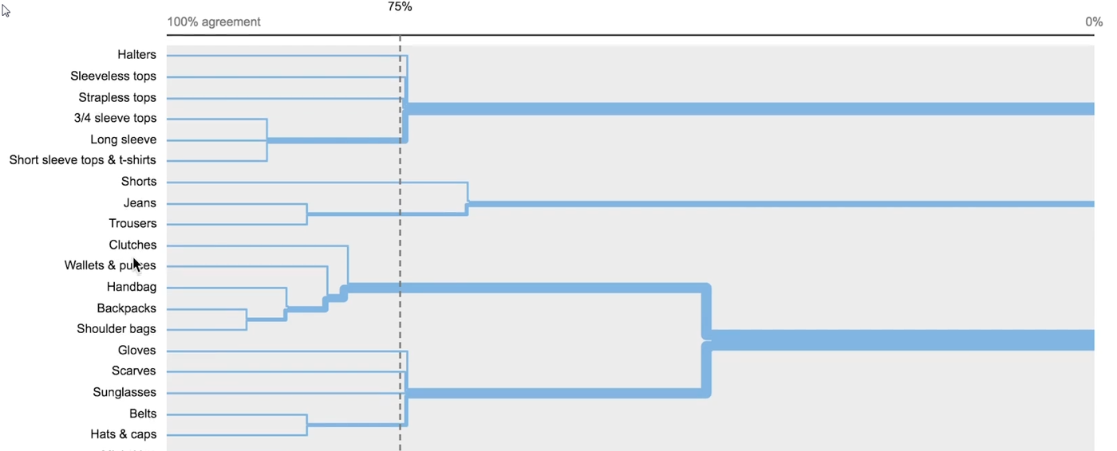

Dendrograms Findings  
The analysis of the Dendrograms showed results similar to those of the Similarity Matrix. The findings are as follows:

**Group 1: Household Component** (see Exhibit 6)  
This group contains the following content items:

* **Subgroup 1 within Household Component**
  + Search for PUFs—Household Component
  + Type of PUFs—Household Component
  + PUF Documentation—Household Component
  + PUF Codebook PDF/HTML—Household Component
  + PUF Programming—SAS, SPSS, Stata—Household Component
  + PUF Data in SAS Format—Household Component
  + PUF Data in Stata Format—Household Component
  + PUF Data in ASCII Format—Household Component
  + PUF Data in XLSX Format—Household Component
* **Subgroup 2 within Household Component**
  + Background information about the MEPS Household Component
  + Standard errors for MEPS estimates for the Household Component
  + Questionnaires for the Household Component
  + Supplemental paper questionnaires for the Household Component
  + Objectives, instruments, and procedures for data collection in the Household Component
  + Panel design and data collection process for the Household Component
  + Response rates for the Household Component
* **Subgroup 3 within Household Component**
  + Link to AHRQ Data Tools for Household Component
  + Household Component Variable Explorer
* **Subgroup 4 within Household Component**
  + Information about the release schedule for PUFs for the Household Component

Exhibit 6: Dendrogram Showing the Household Component Grouping

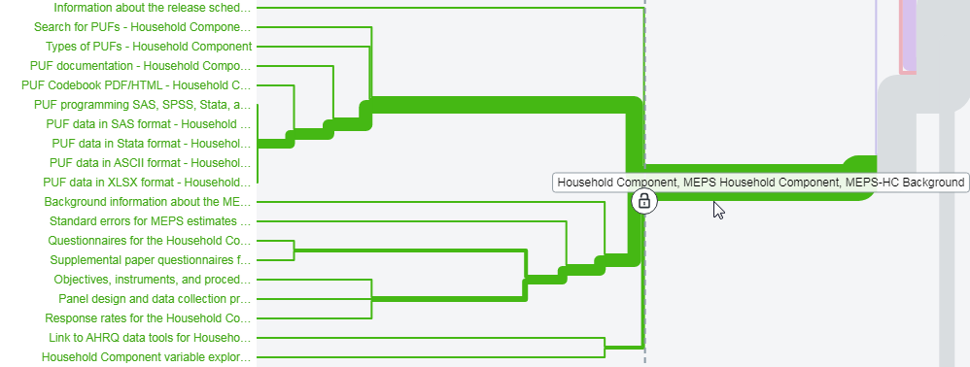

**Group 2: Insurance Component** (see Exhibit 7)  
This group contains the following content items:

* **Subgroup 1 within Insurance Component**
  + Background information about the MEPS Insurance Component
* **Subgroup 2 within Insurance Component**
  + Objectives, instruments, and procedures for data collection in the Insurance Component
  + Private sector establishment questionnaires
  + State and local government questionnaires
  + Sample design and data collection process for the Insurance Component
  + Technical notes and survey documentation
* **Subgroup 3 within Insurance Component**
  + National-level data table for the Insurance Component
  + State- and metro-level data tables for the Insurance Component
* **Subgroup 4 within Insurance Component**
  + Link to AHRQ Data Tools for Insurance Component

Exhibit 7: Dendrogram Showing the Insurance Component Grouping

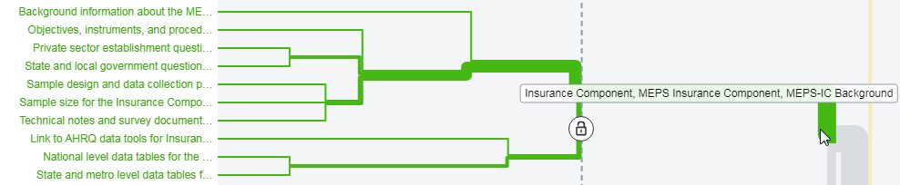

**Group 3: Medical Provider Component** (see Exhibit 8)  
This group contains the following content items:

* **Subgroup 1 within Medical Provider Component**
  + Background information about the MEPS Medical Provider Component
* **Subgroup 2 within Medical Provider Component**
  + Questionnaires for the Medical Provider Component
  + Data elements for the Medical Provider Component
* **Subgroup 3 within Medical Provider Component**
  + Authorization forms for the Medical Provider Component
  + Contacts guides for the Medical Provider Component
* **Subgroup 4 within Medical Provider Component**
  + Sample sizes for the Medical Provider Component
  + Objectives, instruments, and procedures for Medical Provider Component

Exhibit 8: Dendrogram Showing the Medical Provider Component Grouping

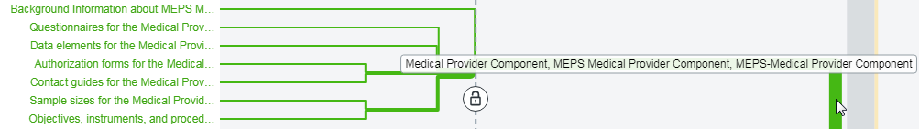

**Group 4: Nursing Home Component** (see Exhibit 9)  
This group contains the following content items:

* Background information about the MEPS Nursing Home Component
* Questionnaires for the Nursing Home Component

Exhibit 9: Dendrogram Showing the Nursing Home Component Grouping



**Group 5: Publications** (see Exhibit 10)  
This group contains the following content items:

* **Subgroup 1 within Publications**
  + Methodology reports
* **Subgroup 2 within Publications**
  + Search for Publications
  + Find Publications by topic
* **Subgroup 3 within Publications**
  + Statistical Brief
  + Chartbook

Exhibit 10: Dendrogram Showing the Publications Grouping

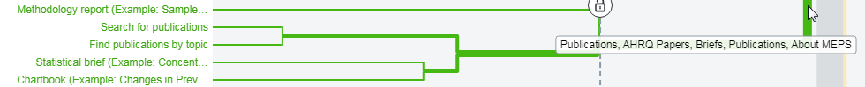

**Group 6: About MEPS or Additional Resources** (see Exhibit 11)  
This group contains the following content items:

* **Subgroup 1 within About MEPS or Additional Resources**
  + Information about MEPS webinars
  + Information about MEPS workshops
  + Information about MEPS conferences
* **Subgroup 2 within About MEPS or Additional Resources**
  + Information about upcoming data sets
  + Information about newly released data sets
* **Subgroup 3 within About MEPS or Additional Resources**
  + Join the MEPS Mailing List

Exhibit 11: Dendrogram Showing the About MEPS Grouping

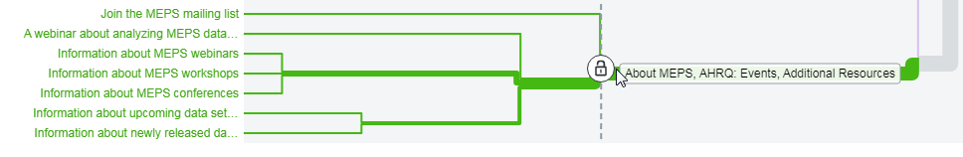

**Group 7: Restricted Data** (see Exhibit 12)  
This group contains the following content items:

* Information on accessing restricted data sets
* Application for access to restricted data sets

Exhibit 12: Dendrogram Showing the Restricted Data Grouping



The Dendrograms provide an extremely clear picture of how the users expect to see items grouped together. They show not only groupings of information but also subgroupings to help determine how information should be structured within each category.

# Recommendations

After analyzing the card sort data from multiple different perspectives, we are confident that a new navigational structure based on our analysis will enhance the user experience. However, the recommendations for a new navigation should be based on not only the card sort analysis but also feedback from the user interviews.

In the user interview analysis stage, we noted that multiple users went to the wrong component section to find information about a different component. Other users mentioned that because they were familiar with the site, they knew where to go without a problem; however, newer users may not realize that PUFs are only for the Household Component or which areas under the Data Release Schedule relate to their specific component.

The card sort data correlated with the user interview data. When analyzing the Dendrogram information, we found a strong user desire to group information by component. For instance, the Household Component section includes PUF Data, Questionnaires/Survey Information, Data Tools, and the Data Release Schedule. The other component sections include similar data as well. This finding helps demonstrate how users want to navigate to their specific component without having to sift through content related to other components. By separating this content, we believe users will no longer be confused easily when they are navigating on the MEPS site.

On the basis of the idea that we would group elements by their component, we recommend testing two options for building out this navigational structure.

## Option 1

* Start the navigation at the component level.
  + Allow the user to select from Household Component, Insurance Component, or Medical Provider Component.
  + Because of the archived nature of the Nursing Home Component, consider placing it in the footer so that it no longer takes up space in the primary navigation.
* Group all content locally under its component.
  + Because the analysis showed subgroups within larger groups, we believe there should be subgroups within each top-level category for better organization.
  + Use dropdowns and megamenus, which allow for multiple hierarchies within the menu item to show the breadth of content within each category.
* Create a standardized menu across all components that contains the following:
  + About
  + Data and Tools
  + Survey Information
  + Publications
  + Resources
* Create global pages available to any component users in the Utility Navigation, including the following:
  + About MEPS
  + MEPS FAQs
  + Topics
  + Contact

**Example of Option 1** (see Exhibit 13)   
[[Example](https://www.figma.com/proto/O2e86M9FCtg5XK8b0M9XDm/Navigation-Prototype-Option-1?node-id=2%3A14&scaling=scale-down&page-id=0%3A1&starting-point-node-id=2%3A14) link removed – see wireframe_links document for most updated mockup]

Exhibit 13: Example Visual Mock-Up of Option 1

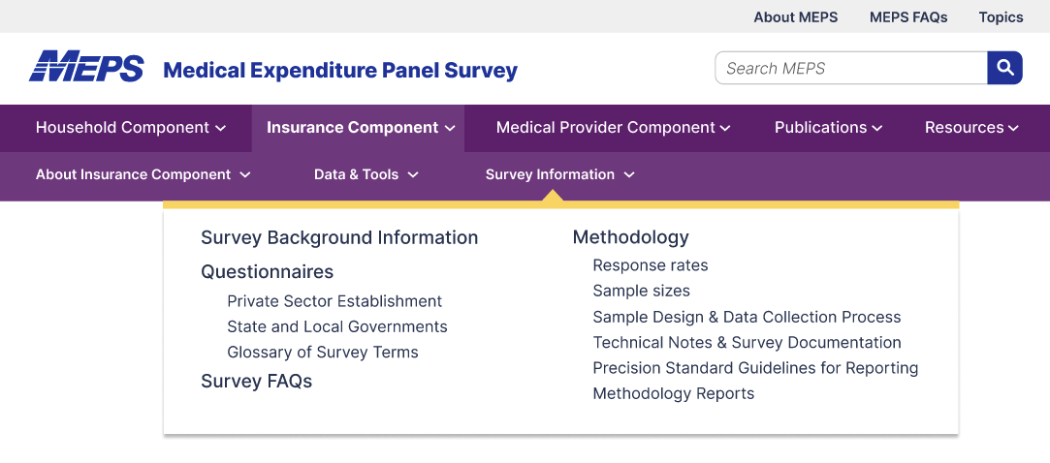

Option 1 Primary Navigation Site Map  
[[Example](https://www.figma.com/proto/O2e86M9FCtg5XK8b0M9XDm/Navigation-Prototype-Option-1?node-id=2%3A14&scaling=scale-down&page-id=0%3A1&starting-point-node-id=2%3A14) link removed – see wireframe_links document for most updated mockup]

Exhibit 14: Option 1 Site Map

|  |  |  |
| --- | --- | --- |
| **Household Component** | **Insurance Component** | **Medical Provider Component** |
| **About**   * About * News * Contact | **About**   * About * News * Contact | **About**   * About * News * Contact |
| **Data & Tools**   * Data Files * Data Tools * Restricted Data Request * Data Release Schedule | **Data & Tools**   * Data Files   - Complete Table Series PDF (on Data Tools page)   * Data Tools * Restricted Data Request * Data Release Schedule | **Data & Tools**   * Restricted Data Request * Data Release Schedule (if needed) |
| **Survey Information**   * Survey Background * Questionnaires - Search Questionnaires - Questionnaires by Section & Year - Supplemental Paper Questionnaires - Interview Showcards by Year - Contact Guides - Authorization Forms - Glossary of Survey Terms * Methodology - Response Rates - Sample Size - Panel Design & Data Collection Process - MEPS Sample Persons In-Scope - Price Indices for Expenditure & Income Comparisons - Standard Errors for MEPS Estimates - Precision Standards Guidelines for Reporting - Methodology Reports * Survey FAQs | **Survey Information**   * Survey Background * Questionnaires -Search Questionnaires - Private Sector Establishment - State and Local Governments - Glossary of Survey Terms * Methodology - Response Rates - Sample Sizes - Sample Design and Data Collection Process - Technical Notes & Survey Documentation - Precision Standards Guidelines for Reporting - Methodology Reports * Survey FAQs | **Survey Information**   * Survey Background * Questionnaires - Search Questionnaires - Contact Guides - Authorization Forms - Glossary of Survey Terms * Methodology - Response Rates - Sample Sizes - Sample Design and Data Collection Process - Technical Notes & Survey Documentation - Data Elements by Provider Type - Methodology Reports * Survey FAQs |
| **Publications**   * Search for Publications * Publications by Type - Statistical Briefs - Methodology Reports - Chartbooks - Working Papers - Research Findings and Highlights - Case Studies | **Publications**   * Search for Publications * Publications by Type - Statistical Briefs - Methodology Reports - Chartbooks - Working Papers - Research Findings and Highlights - Case Studies | **Publications**   * Search for Publications * Publications by Type - Statistical Briefs - Methodology Reports - Chartbooks - Working Papers - Research Findings and Highlights - Case Studies |
| **Resources**   * Workshops * Webinars & Presentations * Conferences * Mailing List | **Resources**   * Workshops * Webinars & Presentations * Conferences * Mailing List | **Resources**   * Workshops * Webinars & Presentations * Conferences * Mailing List |

Option 2  
For Option 2, we would use the same navigational structure that we used for the interior menu from option 1. Option 2 would differ from option 1 in that we would not start the navigation at the component level. Instead, each dropdown option would contain content grouped at the component level where appropriate.   
  
One disadvantage of this approach would be not being able to see third-level pages in the dropdown menu. For instance, we can see the Questionnaires parent page but not the subpages under it within the menu because we are already seeing two levels of navigation.  
  
**Example of Option 2** (see Exhibit 15)  
[[Example](https://www.figma.com/proto/O2e86M9FCtg5XK8b0M9XDm/Navigation-Prototype-Option-1?node-id=2%3A14&scaling=scale-down&page-id=0%3A1&starting-point-node-id=2%3A14) link removed – see wireframe_links document for most updated mockup]

Exhibit 15: Example Visual Mock-Up of Option 2

### Option 2 Primary Navigation Site Map

[[Example](https://www.figma.com/proto/O2e86M9FCtg5XK8b0M9XDm/Navigation-Prototype-Option-1?node-id=2%3A14&scaling=scale-down&page-id=0%3A1&starting-point-node-id=2%3A14) link removed – see wireframe_links document for most updated mockup]

Exhibit 16: Option 2 Site Map

|  |
| --- |
| **About**   * About MEPS * News * Contact |
| **Data & Tools**   * Household Component   + Data Files   + Data Tools   + Restricted Data Request   + Data Release Schedule * Insurance Component   + Data Files   + Data Tools   + Restricted Data Request   + Data Release Schedule * Medical Provider Component   + Restricted Data Request   + Data Release Schedule * Nursing Home Component   + Data Files   + Restricted Data Request |
| **Survey Information**   * Household Component   + Survey Background Information   + Questionnaires   + Methodology   + FAQs * Insurance Component   + Survey Background Information   + Questionnaires   + Methodology   + FAQs * Medical Provider Component   + Survey Background Information   + Questionnaires   + Methodology   + FAQs * Nursing Home Component   + Survey Background Information   + Questionnaires |
| **Publications**   * Publications Search * Publications by Type   + Statistical Briefs   + Methodology Reports   + Chartbooks   + Working Papers   + Research Findings and Highlights   + Research in Action |
| **Resources**   * Events & Webinars - Workshops - Webinars & Presentations - Conferences * Mailing List * FAQs * Contact |

# Conclusions

The card sorting exercise provided us with valuable insight into the mind of the user. AIR was able to understand how users think content on the website should be organized. Through a variety of analysis tools, we looked at how users grouped content items on the site and how they would name or categorize them. Coupling the card sort data with the feedback we gained during the user interview sessions, we think the two options proposed for a new navigational structure are in line with what users expect when they arrive on the MEPS site.

Furthermore, by organizing content by components, it will be easier for advanced users to find what they need quickly and for novice users to avoid being confused about or overwhelmed with the site structure.

For the next steps in restructuring the navigation, we will test the two options to find which one makes the most sense to the user and provides a more error-free experience on the site. From the analysis of this tree test, we would be confident selecting or refining a specific option that will best meet users’ needs.

1. The national-, state-, and metro-level Insurance Component data table cards refer to links directing the user to the datatools.ahrq.gov/meps-ic site.